Project Plan

For Elbrus Mobile Application

Team Eagle

Tran, Duc <>

Truong, Ai <>

Wang, Yunfan <yunfan.wang@sjsu.edu>

# Abstract

With the advance of technology, taking digital pictures and sharing them with friends and family has become an essential part in daily life of many people, especially the young generation. Moreover, the technology also makes those pictures become better in return of taking more spaces.

Traditionally, pictures are stored in local physical hardware, and in order to transfer them, they have be put in USB. That causes the inconvenience for users because they have to carry the USB at all time and cannot share them at the moment. Therefore, being able to upload all pictures onto the cloud and retrieve those to the user’s mobile device at any time would innovate the original form of taking and sharing pictures, especially in the modern time when almost everyone possesses a mobile device with internet accessibility.

The Elbrus Mobile Application is a project that allows user to upload their pictures onto the cloud and retrieve them back on their mobile devices such as phones or tablet. This project will be based on the Android platform since Android has a vast community of users which exceeds the one billion number. The users will be able to make photo albums, friend list, and upload their pictures onto a cloud server, and search for those albums via their android mobile devices.

# Description

Upon opening the application the user will reach the login screen. Here the user can edit the user field and the password field to login. Once logged in the user will reach the album overview screen where the user may press the invite, album create, photo search, album detail buttons. By pressing the invite button the user will reach a new screen that displays their Facebook friends. Here the user can select a friend to send them an invite to join Elbrus. By pressing the album create button the user will reach a new screen allowing them to edit the name and description of the new album. By pressing the photo search button the user reaches a new screen where they can edit user name or description search fields. Once search button is pressed a list of matches will be display on the screen beneath the search field. If a match is selected the user will reach the photo detail screen and be able to view comments or add a new comment by editing the comment field then pressing the submit button. The last button of the album overview screen, album detail, sends the user to the album detail screen. Here the user can select album share, photo create, or photo detail. Album share screen will allow the user to select a friend to share the album with using the same interface as the invite a friend screen. Pressing the photo create button brings the user to a new screen where they may select a photo to upload and edit locations to the photo.

# Platform

Android

# Technology

Database and Server: Parse

Login API: Facebook API

# Architecture

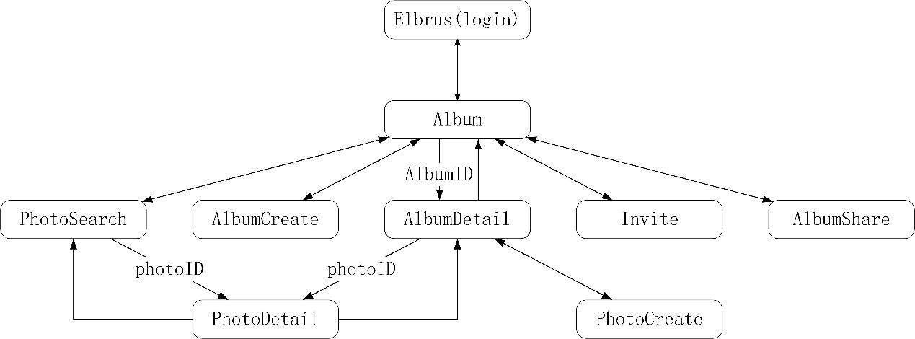

# Milestones

2015-11-12: finish project proposal and plan

2015-11-19: finish architecture design, database design and interface

2015-11-26: finish first demo

2015-12-3: finish testing, report and presentation ppt